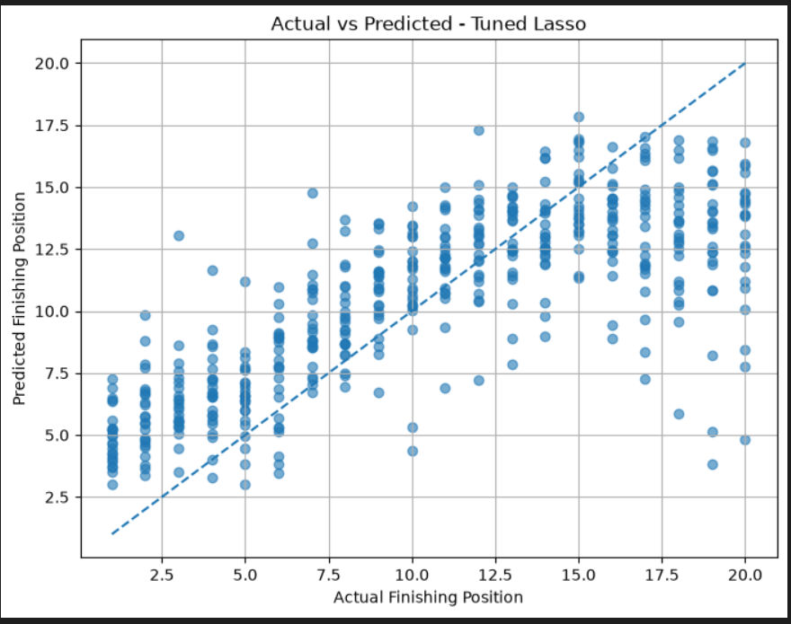
Explain: Actual vs Predicted — Tuned Lasso
This graph shows how well your Tuned Lasso Regression model predicts the actual finishing positions of Formula 1 drivers.
The model predicts a driver's finishing position, and the graph compares that prediction with the driver's actual race result.
1. Understanding the graph
X-axis — Actual Finishing Position
The driver's real position in the race. For example, 1 means first place and 20 means twentieth place.
Y-axis — Predicted Finishing Position
The position predicted by your Tuned Lasso model.
Dashed diagonal line — Perfect prediction
If a point lies on this line, the predicted position exactly matches the actual position.
2. How to read the dots
Each blue dot represents one driver's race result.
Dot on or near the line
The model predicted the finishing position accurately or with a small error.
Dot above the line
The predicted position is numerically higher than the actual position. The model predicted a worse finishing position than the driver achieved.
Dot below the line
The predicted position is numerically lower than the actual position. The model predicted a better finishing position than the driver achieved.
3. What does your graph tell us?
Key observations
1. Predictions cluster around positions 10–15. The model tends to predict finishing positions near the middle of the field.
2. Front-runners are often predicted to finish lower than they actually do. For example, a driver who finishes 2nd might receive a prediction of 5th.
3. Backmarkers are often predicted to finish higher than they actually do. For example, a driver who finishes 20th might receive a prediction of 14th.
4. Some predictions have large errors. Several dots are far away from the dashed line, indicating that the model struggles with certain race results.
4. How does this relate to your model's performance?
Your Tuned Lasso model achieved these results:
Metric | 2025 Test Result
R² Score | 0.4518
RMSE | 4.2618
MAE | 3.3128
The MAE of 3.31 means that the model's predictions differ from the actual finishing positions by about 3.31 places on average.
5. How to explain this in your project presentation
"This scatter plot compares the actual finishing positions with the positions predicted by our Tuned Lasso Regression model. The dashed diagonal line represents perfect prediction. Points closer to this line indicate more accurate predictions, while points farther away represent larger errors. We observe that the model tends to predict positions closer to the middle of the field, sometimes underestimating the performance of top drivers and overestimating that of lower-finishing drivers. This suggests that the model captures some patterns in finishing positions but struggles to predict extreme results accurately."

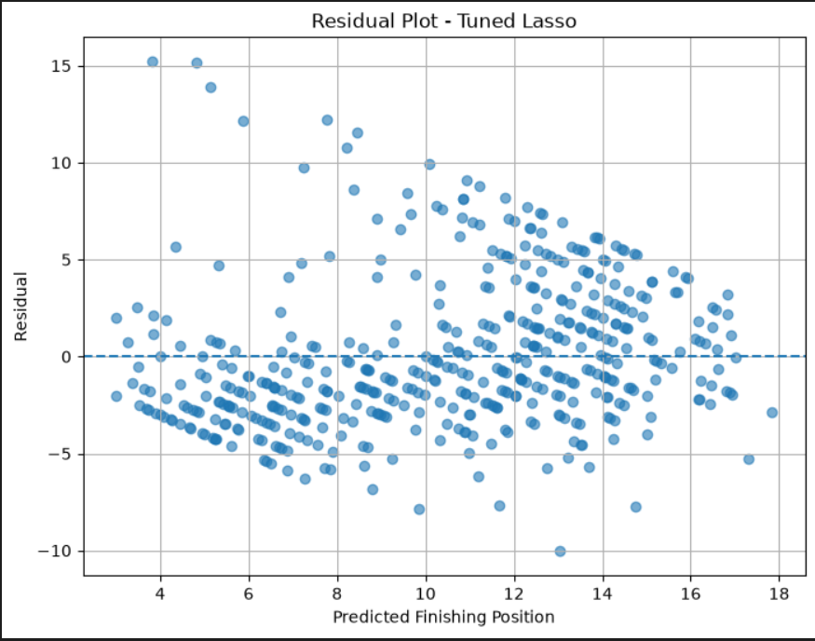

Residual Plot — Tuned Lasso Regression
This graph shows how much your Tuned Lasso model's predictions differ from the actual F1 finishing positions. It helps us understand where the model makes errors and whether those errors follow a pattern.
1. Understanding the graph
X-axis — Predicted Finishing Position
The finishing position predicted by your model.
Y-axis — Residual
The difference between the actual finishing position and the predicted finishing position, assuming your code calculates residual as actual minus predicted.
Dashed horizontal line — Zero residual
This represents a perfect prediction, where actual and predicted positions are equal.
2. How to interpret the dots
Assuming residual = actual position − predicted position:
Positive residual — Above zero
The actual position is numerically higher than the prediction. For example, the model predicted 5th place, but the driver finished 10th. Residual = +5.
Zero residual — On the line
The predicted position exactly matches the actual finishing position.
Negative residual — Below zero
The actual position is numerically lower than the prediction. For example, the model predicted 10th place, but the driver finished 5th. Residual = −5.
3. What does your residual plot tell us?
Key observations
1. Residuals are spread on both sides of zero. This means the model sometimes predicts positions that are too high and sometimes too low.
2. There are some large errors. A few points have residuals above +10 or below −5, indicating substantial differences between actual and predicted positions.
3. The errors appear to follow visible patterns rather than being uniformly scattered. This may indicate that the model behaves differently for different finishing positions.
4. Many residuals fall between approximately −5 and +5. This suggests that many predictions are within five finishing places of the actual result, although there are notable exceptions.
5. The plot contains diagonal bands. These can occur because actual finishing positions are integers while predicted positions are continuous values.
4. How does this relate to your model's performance?
Your Tuned Lasso Regression model's 2025 test results were:
Metric | Result
R² Score | 0.4518
RMSE | 4.2618
MAE | 3.3128
The MAE indicates that the model's predictions differ from actual finishing positions by about 3.31 places on average.
5. How to explain this in your presentation
"This residual plot shows the prediction errors of our Tuned Lasso Regression model. The horizontal dashed line represents zero error. Points above and below this line indicate positive and negative residuals, respectively. We observe that the residuals are spread across a range of values, with some large errors and visible patterns. This suggests that the model captures some relationships in the data but still struggles to predict certain finishing positions accurately."
In simple words: Your actual-versus-predicted graph shows how close the predictions are to the real results, while this residual plot shows how far off those predictions are and whether the errors follow a pattern.

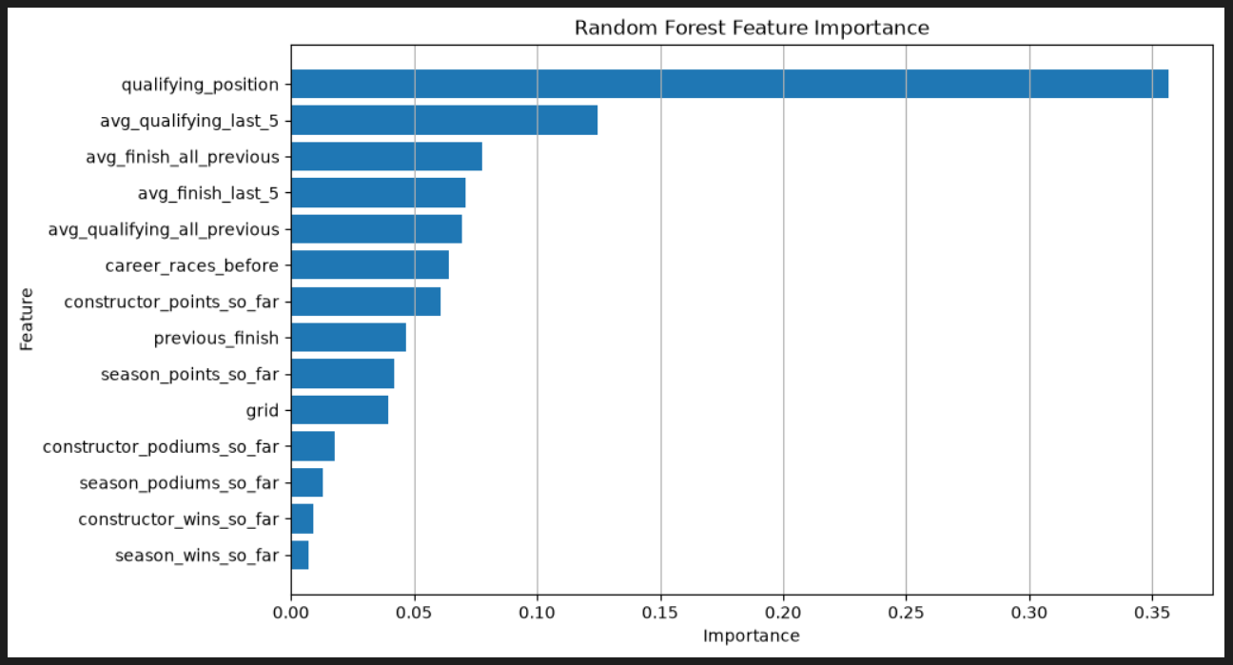
Random Forest Feature Importance — F1Next
This graph shows which input features the Random Forest Regression model considers most useful when predicting a Formula 1 driver's finishing position.
In simple terms, it tells us which data points the model relies on most when making its predictions.
1. Understanding the graph
- Y-axis (Feature): The input variables used by your model.
- X-axis (Importance): The relative importance assigned to each feature by the Random Forest model.
- Longer bar: The feature contributes more to the model's predictions.
- Shorter bar: The feature contributes less to the model's predictions.
Feature importance values are relative and do not represent prediction accuracy or causal influence.
2. Most important features
1. Qualifying Position
~0.356
This is the most important feature in the graph. It means the driver's qualifying position is highly useful to the model when predicting the finishing position.
2. Average Qualifying Position (Last 5 Races)
~0.124
This represents the driver's average qualifying performance across their previous five races.
3. Average Finishing Position (All Previous Races)
~0.077
This captures the driver's historical finishing performance.
4. Average Finishing Position (Last 5 Races)
~0.071
This helps the model use the driver's recent race performance.
5. Average Qualifying Position (All Previous Races)
~0.069
This reflects the driver's historical qualifying performance.
3. Other features
The graph also includes:
Feature | What it represents
career_races_before | Number of races the driver had competed in previously
constructor_points_so_far | Constructor's accumulated points before the race
previous_finish | Driver's finishing position in the previous race
season_points_so_far | Driver's points accumulated in the current season
grid | Starting position on the race grid
constructor_podiums_so_far | Constructor's podium finishes so far
season_podiums_so_far | Driver's podium finishes in the current season
constructor_wins_so_far | Constructor's wins so far
season_wins_so_far | Driver's wins in the current season
The bottom four features have relatively small importance values compared with qualifying position and historical performance.
4. What can we conclude?
Key observations
- Qualifying position dominates the feature importance ranking, with a value around 0.356.
- Qualifying history and finishing history are also important, suggesting that past performance helps the model predict future results.
- Recent and overall performance both contribute to the model.
- Season and constructor statistics have lower importance values in this particular Random Forest model.
This does not mean that the lower-ranked features are useless. Their usefulness can depend on the model, dataset, and other correlated features.
5. How to explain this in your presentation
"This graph represents the feature importance of our Random Forest Regression model. Qualifying position is the most influential feature, followed by average qualifying position over the last five races and average finishing position across previous races. This indicates that a driver's starting position and historical performance are important factors used by the model to predict finishing position. Other features, such as season wins and constructor podiums, have comparatively lower importance."
In one sentence: Your model relies most heavily on qualifying position and historical driver performance when predicting F1 finishing positions.

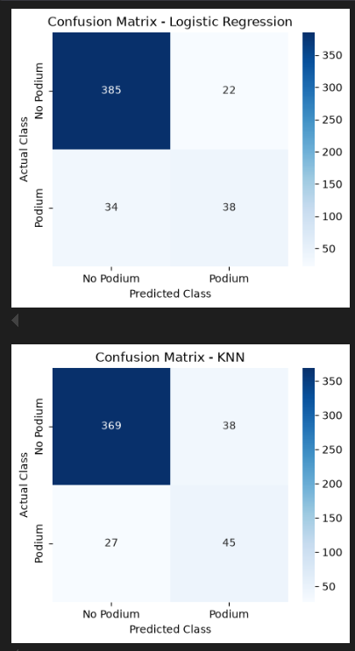
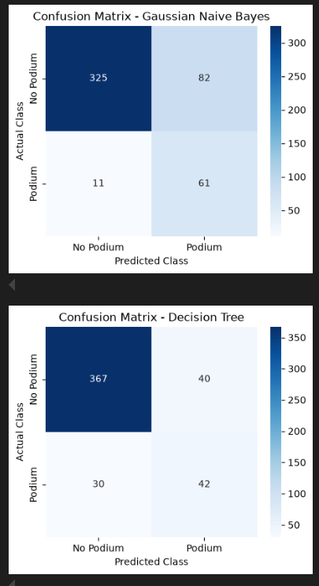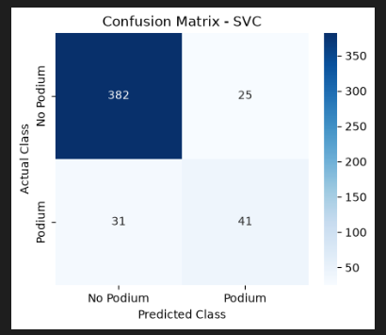

Confusion Matrix — F1Next Classification Models
These five confusion matrices show how well your classification models predict whether an F1 driver will finish on the podium (top 3) or not.
You evaluated five models: Logistic Regression, KNN, Gaussian Naive Bayes, Decision Tree, and SVC.
1. How to read a confusion matrix
The matrices use the following layout:
 | Predicted No Podium | Predicted Podium
Actual No Podium | True Negative (TN) | False Positive (FP)
Actual Podium | False Negative (FN) | True Positive (TP)
- TN: Correctly predicted a driver would not finish on the podium.
- FP: Predicted a podium finish, but the driver did not achieve one.
- FN: Predicted no podium, but the driver actually finished in the top 3.
- TP: Correctly predicted a podium finish.
The diagonal cells (TN and TP) are correct predictions. The other two cells (FP and FN) are errors.
2. Explanation of each model
1. Gaussian Naive Bayes
Accuracy: 80.6%
325
True Negative
82
False Positive
11
False Negative
61
True Positive
Interpretation: It correctly identified 61 podium finishes and missed only 11 actual podiums. However, it incorrectly predicted 82 podium finishes for drivers who did not reach the podium.
2. Decision Tree
Accuracy: 85.4%
367
True Negative
40
False Positive
30
False Negative
42
True Positive
Interpretation: It correctly predicted 42 podium finishes and 367 non-podium finishes. It missed 30 actual podiums and produced 40 false podium predictions.
3. Support Vector Classifier (SVC)
Accuracy: 88.3%
382
True Negative
25
False Positive
31
False Negative
41
True Positive
Interpretation: It correctly predicted 382 non-podium results and 41 podium finishes. It made 25 false podium predictions and missed 31 actual podiums.
4. Logistic Regression
Accuracy: 88.3%
385
True Negative
22
False Positive
34
False Negative
38
True Positive
Interpretation: It correctly predicted 385 non-podium results and 38 podium finishes. It made 22 false podium predictions and missed 34 actual podiums.
5. K-Nearest Neighbors (KNN)
Accuracy: 86.4%
369
True Negative
38
False Positive
27
False Negative
45
True Positive
Interpretation: It correctly predicted 45 podium finishes and 369 non-podium results. It missed 27 actual podiums and made 38 false podium predictions.
3. Model comparison
Here is a summary of the five models based on the confusion matrices.
Model | Correct podiums (TP) | Missed podiums (FN) | False podiums (FP)
Gaussian Naive Bayes | 61 | 11 | 82
Decision Tree | 42 | 30 | 40
SVC | 41 | 31 | 25
Logistic Regression | 38 | 34 | 22
KNN | 45 | 27 | 38
Key takeaway
- Gaussian Naive Bayes identified the most actual podium finishes (61), but also produced the most false podium predictions (82).
- Logistic Regression produced the fewest false podium predictions (22), but missed 34 actual podium finishes.
- SVC and Logistic Regression both correctly classified 423 out of 479 observations, giving approximately 88.3% accuracy.
4. How to explain this in your presentation
"These confusion matrices evaluate the five classification models used in our F1Next project to predict podium finishes. The diagonal cells represent correct predictions, while the off-diagonal cells represent errors. Logistic Regression and SVC achieved 88.3% accuracy, while Gaussian Naive Bayes identified the most actual podium finishes but also generated more false positives. The matrices help us understand how each model handles podium and non-podium predictions beyond overall accuracy."

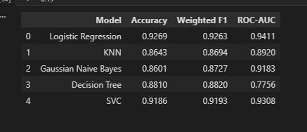
F1Next — Final Classification Results (2025 Test Data)
These results show how well your five machine learning classification models predict whether an F1 driver will finish on the podium (top 3) or not.
You evaluated each model using three metrics: Accuracy, Weighted F1-score, and ROC-AUC.
1. Understanding the three metrics
1. Accuracy
What it means: The percentage of all predictions that were correct.
For example, an accuracy of 0.9269 means the model correctly classified about 92.69% of the test observations.
Higher accuracy means more predictions were correct overall.
2. Weighted F1-score
What it means: A combined measure of precision and recall, calculated for each class and averaged according to the number of observations in that class.
It considers both podium and non-podium predictions, while accounting for class imbalance.
A higher weighted F1-score indicates a better balance between precision and recall across the classes.
3. ROC-AUC
What it means: How well the model distinguishes between podium and non-podium cases across different classification thresholds.
- 1.0 = perfect separation.
- 0.5 = performance equivalent to random ranking.
A higher ROC-AUC means the model is better at ranking actual podium cases above non-podium cases.
2. Your final classification results
Model | Accuracy | Weighted F1 | ROC-AUC
Logistic Regression | 92.69% | 92.63% | 0.9411
KNN | 86.43% | 86.94% | 0.8920
Gaussian Naive Bayes | 86.01% | 87.27% | 0.9183
Decision Tree | 88.10% | 88.20% | 0.7756
SVC | 91.86% | 91.93% | 0.9308
3. Model-by-model explanation
1. Logistic Regression
92.69% accuracy
Accuracy: 92.69%
Weighted F1: 92.63%
ROC-AUC: 0.9411
Logistic Regression correctly classified approximately 93 out of every 100 test observations. Its ROC-AUC of 0.9411 indicates strong ability to distinguish podium and non-podium cases across thresholds.
2. K-Nearest Neighbors (KNN)
86.43% accuracy
Accuracy: 86.43%
Weighted F1: 86.94%
ROC-AUC: 0.8920
KNN uses the similarity between a driver's data and nearby observations to make predictions. Its results show reasonable classification performance, with a ROC-AUC of 0.8920.
3. Gaussian Naive Bayes
86.01% accuracy
Accuracy: 86.01%
Weighted F1: 87.27%
ROC-AUC: 0.9183
Gaussian Naive Bayes achieved a weighted F1-score higher than its accuracy. Its ROC-AUC of 0.9183 indicates that it can distinguish the two classes reasonably well, even though its overall accuracy is lower than that of Logistic Regression and SVC.
4. Decision Tree
88.10% accuracy
Accuracy: 88.10%
Weighted F1: 88.20%
ROC-AUC: 0.7756
Decision Tree achieved an accuracy of 88.10%, but its ROC-AUC is lower than those of the other models. This suggests that its ability to rank podium cases across different thresholds is more limited.
5. Support Vector Classifier (SVC)
91.86% accuracy
Accuracy: 91.86%
Weighted F1: 91.93%
ROC-AUC: 0.9308
SVC achieved strong classification results, with high accuracy and weighted F1-score. Its ROC-AUC of 0.9308 indicates good class separation across thresholds.
4. Visual comparison
0%25%50%75%100%
Logistic Reg.
KNN
Naive Bayes
Decision Tree
SVC
5. What can we conclude?
- Logistic Regression has the highest accuracy (92.69%), weighted F1-score (92.63%), and ROC-AUC (0.9411) among the five models in this 2025 test evaluation.
- SVC also achieved strong results, with 91.86% accuracy and a 0.9308 ROC-AUC.
- Gaussian Naive Bayes has a lower accuracy but a relatively high ROC-AUC of 0.9183.
- Decision Tree has a comparatively lower ROC-AUC of 0.7756.
Important: These metrics describe performance on your 2025 test dataset. They do not guarantee the same performance on future F1 seasons.
6. Presentation-ready explanation
"We evaluated five classification models on the 2025 test dataset to predict whether a Formula 1 driver would finish on the podium. We used Accuracy, Weighted F1-score, and ROC-AUC to measure model performance. Logistic Regression achieved 92.69% accuracy, a weighted F1-score of 92.63%, and a ROC-AUC of 0.9411. SVC also performed strongly, with 91.86% accuracy and a ROC-AUC of 0.9308. These results show that both models were able to classify podium and non-podium outcomes effectively on the test data."

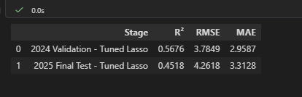

F1Next — Final Regression Summary
Your Tuned Lasso Regression model predicts the finishing position of Formula 1 drivers. The table compares its performance on the 2024 validation dataset and the 2025 final test dataset.
1. Final results
Stage | R² Score | RMSE | MAE
2024 Validation | 0.5676 | 3.7849 | 2.9587
2025 Final Test | 0.4518 | 4.2618 | 3.3128
2. Understanding the metrics
- R² Score: Measures how much variation in finishing positions the model explains. On the 2025 test data, the score was 0.4518.
- RMSE: Measures prediction error, giving larger errors more weight. The test RMSE was 4.2618 positions.
- MAE: Measures the average absolute difference between predicted and actual positions. The test MAE was approximately 3.31 positions.
3. What do the results tell us?
- The model performed better on the 2024 validation data than on the 2025 test data.
- The R² score decreased from 0.5676 to 0.4518, indicating that the model explained less variation in the 2025 results.
- The MAE increased from approximately 2.96 to 3.31 positions, meaning the average prediction error was larger on the test data.
- The results suggest that predicting finishing positions in a later season is challenging for this model.
4. Presentation-ready explanation
"We evaluated our Tuned Lasso Regression model using the 2024 validation dataset and the 2025 final test dataset. On the 2025 test data, the model achieved an R² score of 0.4518, an RMSE of 4.2618, and an MAE of 3.3128. This means that the model's predictions differed from the actual finishing positions by approximately 3.31 places on average. The decrease in R² and increase in prediction error compared with validation indicate that the model faced greater difficulty predicting the 2025 race results."

